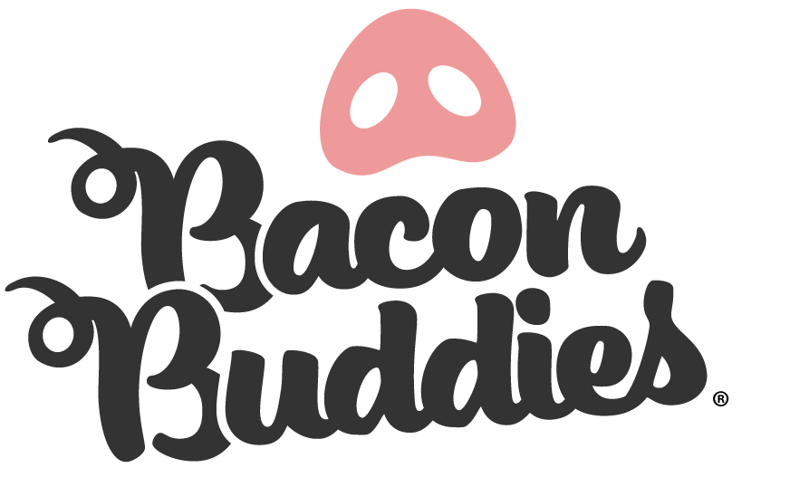
(County Name) County Bacon Buddies® Volunteer

Dear Supporter of (County Name)
(County Name) is very excited to have the opportunity to bring Bacon Buddies® to this years (County Name) County Fair. Bacon Buddies® is an event that was created in hopes to integrate people with intellectual and/or developmental disabilities (Buddies) with 4-H/FFA members to give the athletes an opportunity that they otherwise would not receive. During this event, a 4-H or FFA member is paired up with a buddy to exhibit a pig! This program also allows the next generation of pig farmers to give back to their communities while giving an opportunity to the athletes.
The (County Name) Bacon Buddies® event will be held on (date) at (time) at the (location). An event like this requires many hands to provide a great experience for participants. If you would like to be involved as a volunteer, please complete and submit the information below.

Volunteer Name: ___________________________________________________________________________
Address: __________________________________________________________________________________
City/State/Zip:______________________________________________________________________________
Email Address: ______________________________________Cell Phone: ______________________________
Age (circle): Adult Youth
T-Shirt (circle): Adult Size S M L XL XXL Youth Size S M L XL
Parent/Legal Guardian Name(s): _______________________________________________________________
Submit registration form and release to:
(County Name) County Fair
Address: (Information)
Email: (Information)

Please send in consent and registration form postmarked by (Date of Deadline)

